

Heritage Victoria
Catalogue Template

V1.15

Users Guide

Table of Contents
1. Overview: 3
2. Purpose: 3
3. Prerequisites 4
4. Using the Form 4
4.1 Opening the Object Data Catalogue 4
4.2 Opening a new Form 5
4.3 Entering Different Data Types 6
4.4 Submitting Data 7

Overview:

The Heritage Victoria Catalogue Template is an Excel database to be used when cataloging artefacts from historical archaeological sites prior to submission to Heritage Victoria. The excel spreadsheet is used to format and validate the data prior to being loaded into Heritage Victoria’s central database, and subsequently made available via the Heritage Victoria website. This will ensure that all artefact assemblages are catalogued consistently, thereby maximizing their research potential, and facilitating cross-assemblage analysis. Terminology contained in drop-down lists is controlled, and certain fields are mandatory.

Purpose:

This document is a ‘how to’ guide for common tasks which would be performed within the Catalogue Template. The guide will show users how to perform the various functions available from within the Catalogue Template.

Prerequisites

For optimum use, the following are pre-requisites for using the Catalogue Template

- Microsoft Office Excel 2003 or 2007
- Windows Operating system (XP, Vista, 7)
- Recommended Screen resolution of 1280 x 1024

Using the Form

Opening the Catalogue Template

- The catalogue contains visual basic macros that will only work if your macro security settings are set correctly. You need to adjust your security settings manually through the Trust Centre (Excel 2007) or Macro Security (Excel 2003). Macros must be enabled for the catalogue to work correctly. To enable macros in Excel 2003, use the Tools menu, and select Macro>Security. Set security to medium. To enable Macros in 2007 select the Office button and then the Excel Options button in the bottom left hand corner. Choose the Trust Centre as indicated below.
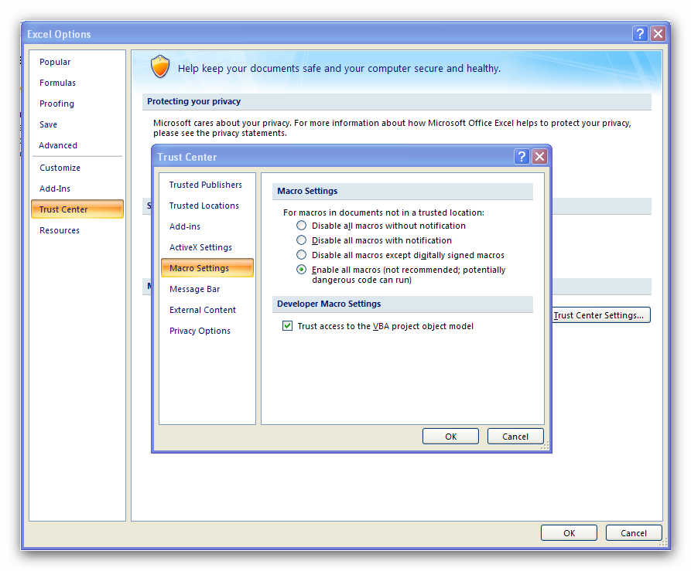

Opening a new Form

- From the data entry sheet click on the button labeled ‘Object Data Input’.

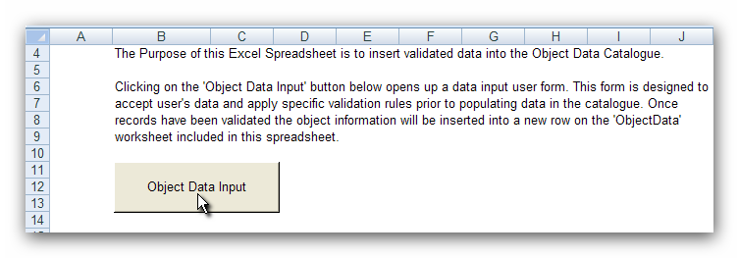

- A new form will appear in the window.
- Start to enter the details for the object in each of the allocated fields.
- Fields marked in red are required fields; the form will not allow you to submit data without these fields populated.

Entering Different Data Types

- Some fields are configured to only accept certain data types. A prompt will appear if the incorrect data type is entered.

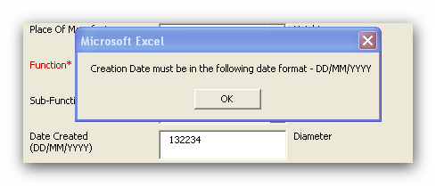

- Screen tips will appear when you hover over fields indicating what sort of data is required.
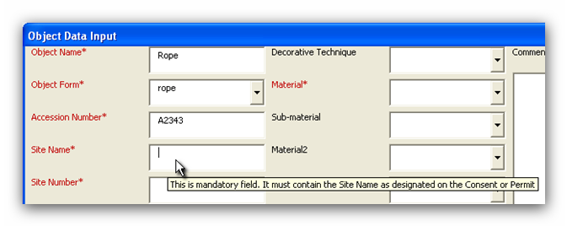

- There are a number of drop down lists within the form. Some of these lists are linked. For instance the Function and Sub-Function lists are linked. The Sub-Function list will show options relating to the Function list. If you change the option selected in the Function list, the options in the Sub-Function list will change.

Submitting Data

- After filling in the form with data for each object, press the ‘Submit’ button. This will transfer the data from the form into the ‘Object Data’ sheet.

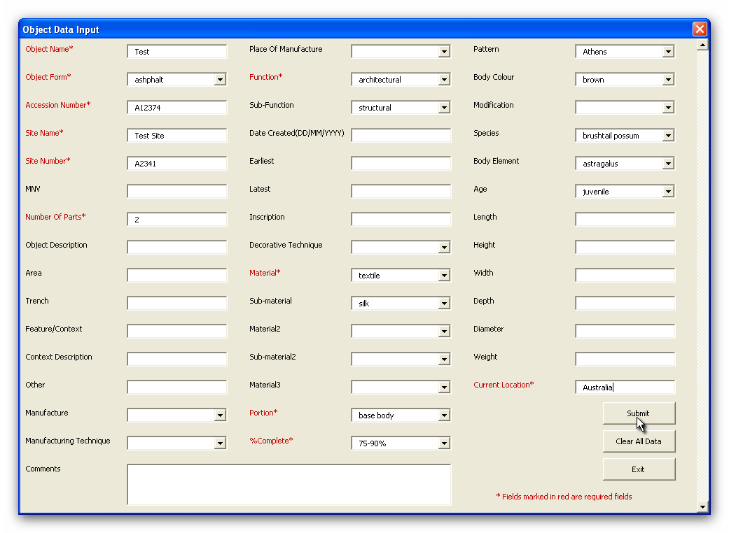

- After submitting data, two fields will remain populated (Site Name and Site Number). This will save time when submitting multiple objects from the same site. To clear all data from the form, press the ‘Clear All Data’ button.

- Once the data has been inserted into the ‘Object Data’ worksheet, the worksheet has protection in place to prevent users from editing data. There is a feature within the worksheet to allow users to delete whole rows of data. Select the row you want to delete and press the ‘Delete Selected Row’ button.

- There is an option that allows data in the worksheet to be recalled to the data interface and edited. To use this, select the row that requires editing and click the ‘Edit Selected Row’ button.
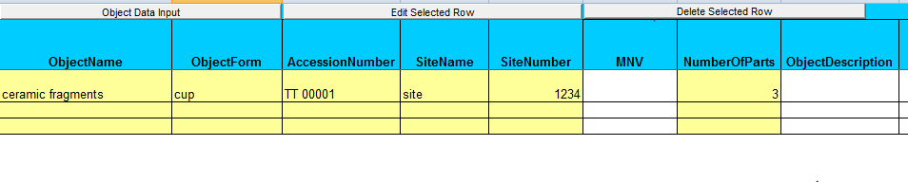

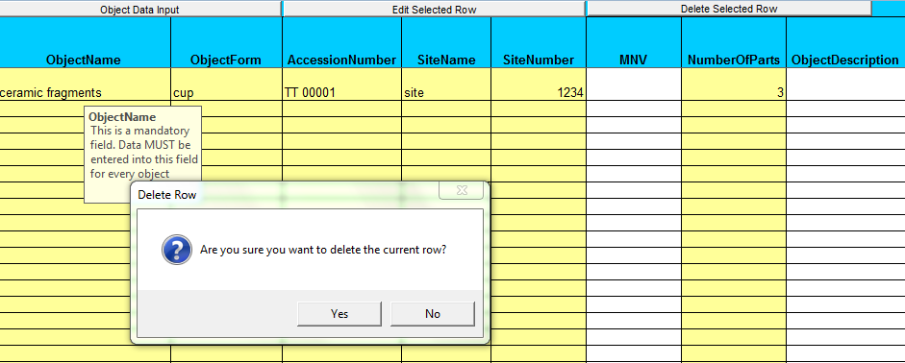

Appendix 1

Artefact Sorting Guidelines:

Below are a few pointers to aid the sorting of artefact assemblages for cataloguing:

- Artefacts should be sorted in the following order:

- by feature or context

- by broad material type, for example, ceramic, glass, metal, leather, wood etc

- by more specific material type, for example, within ceramic, sort into porcelain, earthenware, stoneware, pipe clay etc

- ceramic material can be sorted by pattern; glass can be sorted by colour

- by vessel type, for example, fragments from plates, or fragments from cups can be grouped together

- fragments that come from the same vessel or object should be grouped together and allocated an individual catalogue number

- Each catalogue entry should contain only one material type, unless the object itself is composite. For example, porcelain fragments should not be catalogued under the same entry as stoneware fragments, or metal fragments, unless the fragments constitute one item.

- All efforts should be made to catalogue fragments from individual vessels or objects together.

- If an item is complete or near complete, it should be allocated an individual number, not catalogued as part of a group. For example, 2 or more complete, or near complete bottles should not be catalogued together.

- If a number is allocated to a group of fragments that cannot all fit into one box, then it is too big. The group must be split.

Appendix 2

Cataloguing Field Definitions

Object Name: Mandatory field. This is a free-text field that briefly describes the artefact. A more specific description than Object Form.

Object Form: Mandatory field. This is a short field controlled by a look-up list. It denotes the form of the original object, ie. cup, plate, bottle, pipe, brick etc. For fragmented items, give the name of the form when item complete (eg cup, for a rim or body fragment of a cup); if however, item is self contained and is a component, rather than a fragment of something, use its own form (eg rivet, eyelet)

Accession Number: Mandatory field. This is the unique number allocated to the object.

Site Name: Mandatory field. Name of the site the artefact was sourced from as cited on the Consent or Permit.

Site Number: Mandatory field. Heritage Inventory or Victorian Heritage Register number allocated to the site the object is from, as cited on the Consent or Permit.

MNV: Use to indicate the Minimum Number of Vessels accounted for in this record.

Number of Parts: Mandatory field. Indicates how many items/fragments included in the record. Numeric field.

Object Description: More lengthy detailed description of object. This field holds enhanced description and non-critical data that does not fit into other fields. Although not mandatory, this field should be populated as it will be used to describe the object online.

Area: Refers to area on site the artefact was retrieved from. Use this to record the broadest division of a site during field work.

Trench: If using trenches, record trench designations here.

Feature/Context: Use this to record smaller excavation units: features or contexts or stratigraphic unit.

Feature/Context Description: A brief description of the feature or context eg, rubbish pit, or under-floor surface, yellow clay deposit etc. Can be used to record relationships between contexts (eg to indicate which contexts may all come from a deposit of interest, such as a cess-pit), or which phases a context may relate to.

Other: Use this field to indicate any other unit of excavation that may be relevant

Manufacturer: Name of company or individual that manufactured the original object.
Manufacturing Technique: Short field controlled by look-up list that describes method used to manufacture object.

Place of Manufacture: Short field controlled by look-up list. Indicates country of origin.

Date Created: Use for objects with definite manufacturing date, such as coins, newspaper fragments.

Earliest: Use to indicate earliest possible date an object could have been manufactured.

Latest: Use to indicate latest possible date an object could have been manufactured.

Function: Mandatory field – if unknown or indeterminate, use Unknown. Use to indicate broad category of function of object at point of manufacture. Controlled by hierarchical look-up list.

Sub-Function: Use to indicate more specific function of object at point of manufacture. Controlled by hierarchical look-up list

Inscription: Free-text field used to describe and transcribe any inscriptions or maker’s marks on the object.

Decorative Technique: Field used to describe technique used to decorate object, eg transfer print, embossing, rouletting, inscribing. Controlled by look-up list.

Material: Mandatory field. Field used to describe primary, broad material object consists of, eg. Ceramic, metal, glass etc. Controlled by hierarchical look-up list.

Sub-material: Field used to describe more specific material object made of, eg, earthenware, porcelain, copper alloy. Controlled by hierarchical look-up list.

Material2: Used for composite objects only. Use to indicate secondary material object made of. Controlled by hierarchical look-up list.

Sub-material2: Used for composite objects only. Use to describe more specific secondary material object made of. Controlled by hierarchical look-up list.

Material3: Used for composite objects only, when 2 fields not enough to indicate all materials. Controlled by hierarchical look-up list.

Portion: Mandatory field. Use to indicate which portion of object represented. Controlled by drop-down list.

% complete: Mandatory field. Use to indicate how much of original object is present. Controlled by drop-down list.

Pattern: Use to indicate specific name of pattern on object, where it is known. Use mainly for ceramics, although some clay pipes may have named patterns. Look-up list.

Body Colour: Use to indicate colour of body of object. Designed to describe ceramic and glass bodies. Look-up list.

Modification: Use to indicate any modification made to object after manufacture, but before collection, excluding breakage – repairs, inscriptions, butchery, animal activity. Use for faunal and non-faunal items

Species: use for faunal items. Use to indicate species of animal. Deliberately broadly-conceived to capture broad classes and specific taxons. Common names are used. Controlled by look-up list

Body Element: Use for faunal items. Use to indicate what part of animal body is represented. Controlled by look-up list.

Age: Use for faunal items. Use to indicate approximate age of animal at time of slaughter.

Length: Use to indicate Length of object (where appropriate). Millimetres are preferred unit.

Height: Use to indicate height of object (where appropriate). Millimetres are preferred unit.

Width: Use to indicate width of object (where appropriate).

Depth: Use to indicate depth of object (where appropriate). Millimetres are preferred unit.

Diameter: Use to indicate diameter of object (where appropriate). Millimetres are preferred unit.

Weight: Use to indicate weight of object. Grams are preferred unit.

Location: Mandatory field. Use this field to indicate the box the object is stored in.

Acknowledgements

Thanks to the following individuals and organisations who provided feedback and assistance
during the development of this template:

Sarah Hayes
Susan Lawrence
Peter Davies
Jeremy Smith
Alasdair Brooks
Adrienne Ellis
Ilka Schacht
Cathy Tucker
Susie Collis
Penny Crook
Tim Murray
Hanna Steyne
British Museum Materials Thesaurus
Paul Adams (English Heritage)
Isa Loo
Martin Jones
Sarah Mason
Peter Harvey
Richard Jones

